KNOWLEDGE GRAPH EXTRACTION FROM UNSTRUCTURED DOCUMENTS

A PROJECT PHASE-3 REPORT

CHAPTER 9: UML DIAGRAMS

Use Case Diagram
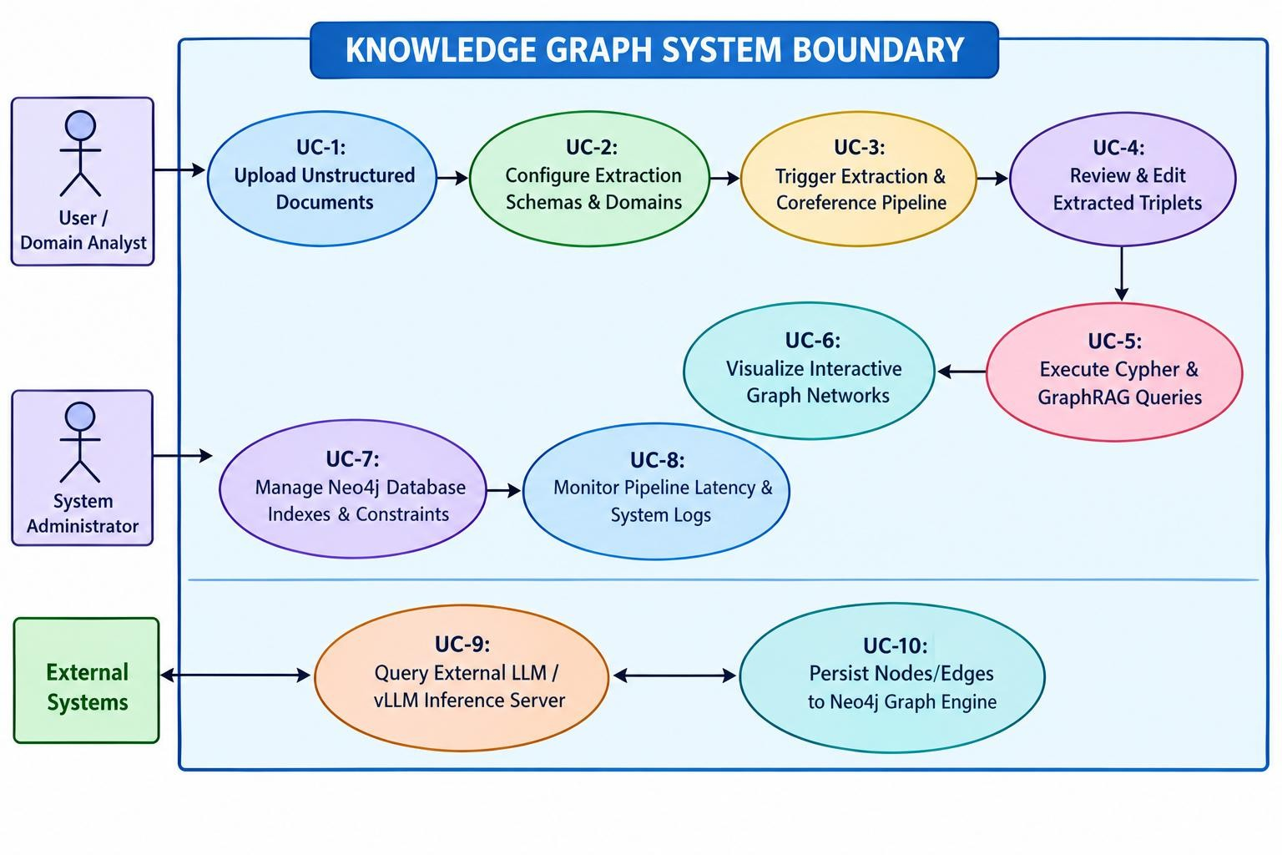
The Use Case Diagram defines the functional boundary of the system, illustrating how primary human actors (System Administrator, Domain Analyst) and external automated systems (Neo4j Engine, LLM Provider) interact with system capabilities:

Illustrates interactions between primary actors (User / Administrator) and system features, including document uploading, extraction trigger, Cypher graph query execution, and visual GraphRAG question-answering.

Sequence Diagram
The Sequence Diagram models the continuous step-by-step messaging sequence across object lifelines during an automated document extraction cycle:

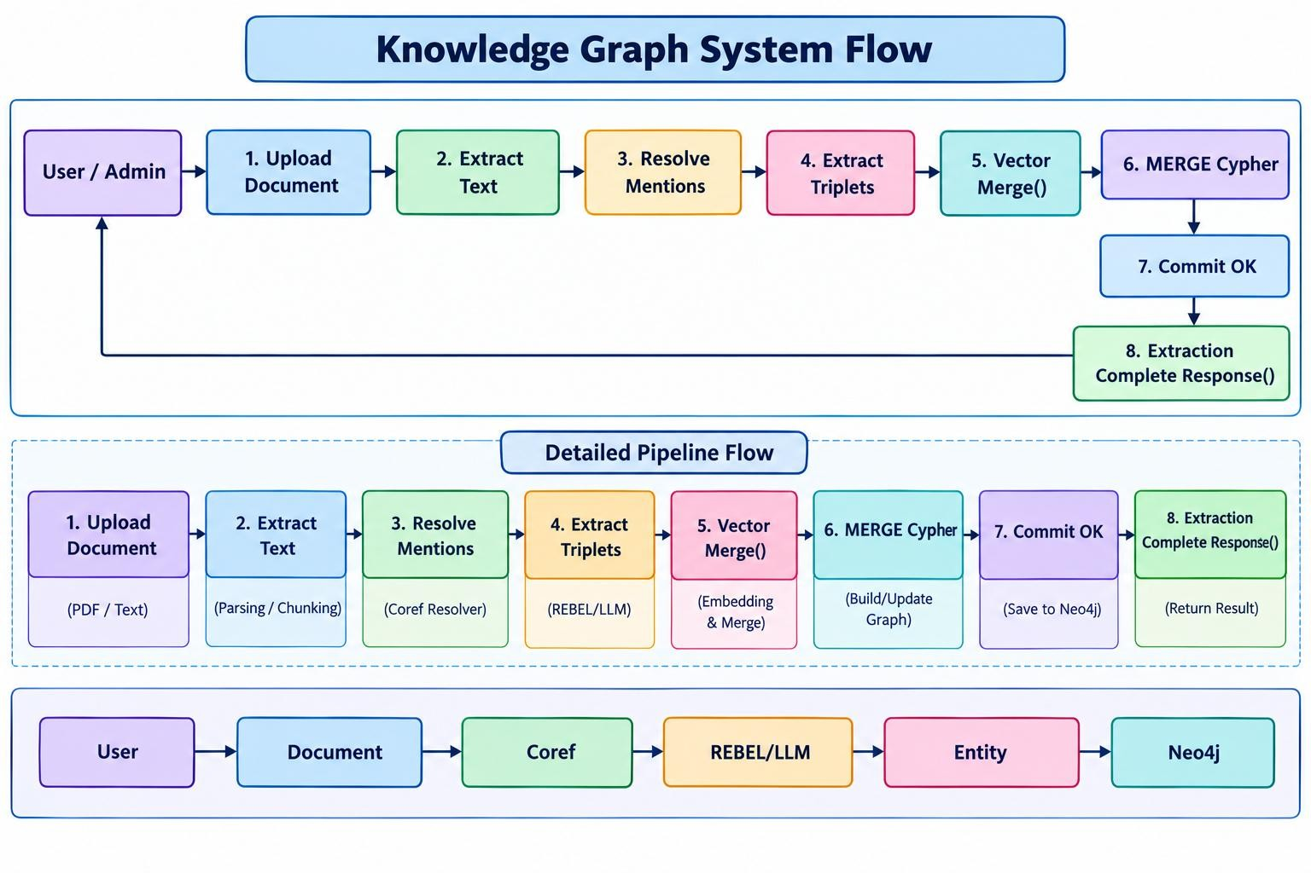
Details the sequential message calls between the Ingestion Service, Coreference Resolver, LLM/REBEL Extraction Engine, and the Neo4j Graph Database persistence layer.

Activity Diagram
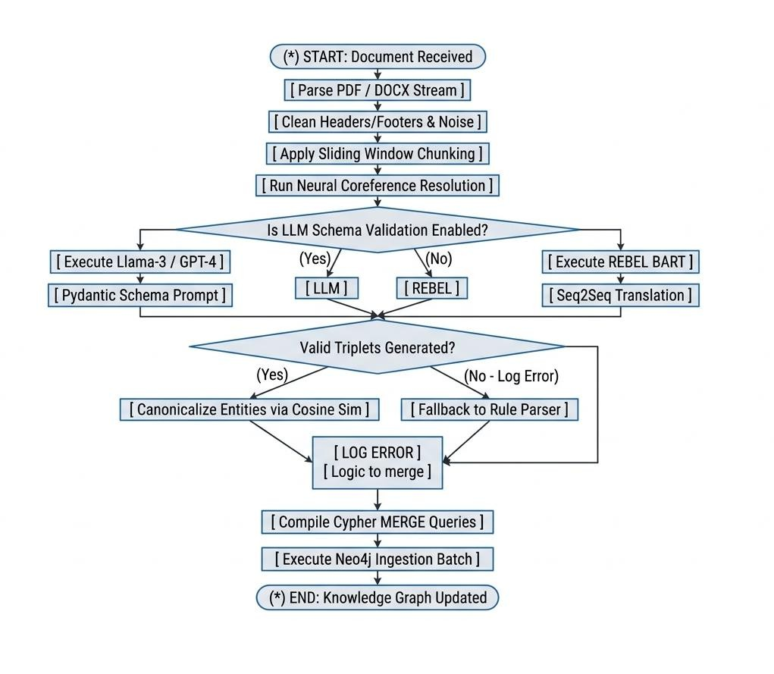
The Activity Diagram tracks operational flow, branching decisions, and error-handling routines across document processing execution:

